CURTIN ISAD 3000 · PROJECT PORTAL
User Acceptance Testing (UAT) Document
Curtin ISAD 3000 Project Portal
Project | Curtin ISAD 3000 Project Portal
Document ID | CP-UAT-001
Version | 4.0
Date | 25 October 2026
Author | Darren
Status | Draft for review
Classification | Internal

This document defines how the Curtin ISAD 3000 Project Portal is accepted by its business users. It sets out the scope, approach, environment, roles, entry and exit criteria, test data and a full set of scripted test cases with expected results, followed by defect logging, execution summary and sign-off templates.

Document Control

Document information
Document title | User Acceptance Testing (UAT) Document
Document ID | CP-UAT-001
Project | Curtin ISAD 3000 Project Portal
Document type | User Acceptance Test plan and test cases
Version | 4.0
Author | Darren
Date issued | 25 October 2026
Status | Draft for review
Classification | Internal
Intended audience | Lecturers (business owners), UAT testers, project team, QA

Revision history
Version | Date | Author | Description of change
1.0 | 21 October 2026 | Darren | First full-length version.
2.0 | 23 October 2026 | Darren | Added Lessons & Videos and maintenance notice test modules.
3.0 | 23 October 2026 | Darren | Updated for the later 23 October 2026 changes: lecturer-managed lessons (add, validate, play, download, delete), Student / Lecturer sign-in choice, new screenshots and 16 more test cases (105 in total).
4.0 | 25 October 2026 | Darren | Updated for the account change: Sign in and Create account tabs, role stored with the account, approved-lecturer rule; sign-in test cases replaced (110 in total).

Review and approval
Role | Name | Signature | Date
Author | Darren |  | 25 October 2026
Reviewer
Approver

Related documents
Document ID | Title
CP-SRS-001 | Software Requirements Specification
CP-UAT-001 (this document) | User Acceptance Testing (UAT) Document
CP-UG-001 | User Guide
CP-LG-001 | Login Guide

Table of Contents

1. Introduction

1.1 Purpose
The purpose of User Acceptance Testing is to confirm, from the point of view of the people who will use the Portal, that the system does what the Software Requirements Specification (CP-SRS-001) says it must do and is fit to be released. UAT is performed by lecturers and representative students, not by the developers, using realistic scenarios and data.

1.2 Scope

In scope
- Passwordless sign-in with an emailed 6-digit code, including all error and limit conditions.
- Route protection, session handling and sign-out.
- Role-based behaviour for Lecturers and Students.
- Project directory: loading, cards, search, filters, ordering and project detail window.
- Lessons & Videos: student viewing, lecturer upload (documents, video file, YouTube link), validation limits, download, delete and access control.
- Sign in and Create account tabs, account roles (Student, approved Lecturer) and lecturer-only restrictions.
- Maintenance notice: display, dismissal, per-account behaviour and publishing a new notice.
- Platform acceptance: health endpoint, security headers, browser and device compatibility, accessibility basics, release controls.

Out of scope
- Load and penetration testing (a separate technical activity).
- Email-provider internals (only delivery and content are checked).
- Features not in the SRS, such as password login or per-project editing.

1.3 Objectives
# | Objective
1 | Verify that every Must requirement in CP-SRS-001 has passed at least one test case.
2 | Confirm that approved users can sign in and unapproved users cannot obtain access.
3 | Confirm that students can find a suitable project quickly using search and filters.
4 | Identify defects, usability problems and documentation gaps before go-live.

1.4 References
Document | Use in UAT
CP-SRS-001 Software Requirements Specification | Source of requirement IDs (FR-nn, NFR-nn) and expected behaviour.
CP-UG-001 User Guide | Reference for how testers should operate the screens.
CP-LG-001 Login Guide | Reference for the sign-in procedure and its messages.
scripts/smoke.mjs, tests/integrity.test.mjs | Automated checks used in UAT-PLAT-03 and UAT-PLAT-04.

2. Test approach

2.1 Approach
UAT is scenario based. Each test case has an ID, preconditions, numbered steps, an expected result, the requirement(s) it proves and a priority. The suite contains 110 test cases in 8 modules. Testers run the steps exactly as written, record Pass, Fail or Blocked, attach evidence (screenshots) for every failure and log defects in the defect log (Section 6).

2.2 Roles and responsibilities
Role | Responsibility
UAT lead | Plans the cycle, assigns test cases, tracks progress, reports results and requests sign-off.
Lecturer testers | Execute role-display tests with Lecturer accounts and confirm business suitability of the directory.
Student testers | Execute sign-in, search, filter and project-detail tests from the student perspective.
Development team | Prepare the test environment, supply test data, investigate and fix defects, re-release for retest.
System administrator | Provides email delivery, ALLOWED_EMAILS and database settings; runs platform checks.
Approver | Reviews the results and signs the acceptance statement.

2.3 Test environment
Item | Requirement
Environment | Test (digital twin) deployment on the test branch, or a dedicated UAT deployment. Live should not be used for tests that deliberately cause errors.
Email | Working SMTP or Resend configuration; testers must be able to read the mailbox of every test email.
Configuration | SESSION_SECRET set; ALLOWED_EMAILS set to the approved test accounts plus none of the "outsider" addresses; AUTH_DEV_ECHO unset (except for UAT-AUTH-19 on a non-production build).
Browsers | Latest Chrome, Edge, Firefox and Safari; one phone or emulator at 375 px width.
Tools | Browser developer tools; an API client (curl or Postman) for API-level cases.
Baseline data | Bundled 2,500 projects. Counts in the test cases assume this baseline.

2.4 Entry criteria
- CP-SRS-001 is approved and the build under test is identified (version or commit shown by /api/health).
- npm run check passes for the build (typecheck, lint, tests, build).
- Test environment, accounts, mailbox access and test files (Section 3) are ready.
- Testers have read the User Guide and Login Guide.

2.5 Exit (acceptance) criteria
Criterion | Threshold
Execution | 100% of High priority and at least 95% of all test cases executed.
High priority pass rate | 100% passed.
Overall pass rate | At least 95% passed.
Critical or High severity defects | None open.
Medium severity defects | Each has an agreed fix date or documented workaround.
Sign-off | Approver signs Section 9.

2.6 Defect severity
Severity | Definition | Example | Target response
Critical | System unusable, security breach or data loss. | A user can reach the directory without signing in; session can be forged. | Fix before testing continues
High | Major function fails with no workaround. | Correct code is rejected; directory does not load. | Fix before release
Medium | Function impaired, workaround exists. | Filter chip not highlighted; wrong toast text. | Fix in next release or agreed date
Low | Cosmetic or documentation issue. | Misaligned text; outdated help note. | Backlog

2.7 Result status legend
Status | Meaning
Pass | Actual result matches expected result.
Fail | Actual result differs; log a defect with evidence.
Blocked | Cannot run because of an environment problem or another open defect.
N/A | Not applicable in this environment (state why).

2.8 Execution procedure
- Confirm the build identifier from /api/health and note it on the execution summary.
- Run the test cases module by module in the order shown (sign-in first, because other modules need a session).
- For each case, tick one result box, enter your initials and the date, and add comments.
- Take a screenshot for every failure and note the exact message shown.
- Log each defect in Section 6 with its test case ID and severity.
- After fixes, retest failed cases and run a short regression of High priority cases.
- Complete the summary (Section 7) and request sign-off.

3. Test data and accounts

3.1 Test accounts
The Portal has no passwords. A tester signs in by receiving a code at the account's email address, so the tester must control the mailbox. Use the seeded accounts below, or replace them with the testers' own addresses in the test database and ALLOWED_EMAILS.
Name | Email | Role | Used for
Murphy Choy | murphy.choy@icloud.com | Lecturer | Lecturer header, from redirect
Goladin | goladin@gmail.com | Lecturer | Second Lecturer account
Dang Tran | tranphucdang0709@gmail.com | Student | Student journeys, initials "DT"
Learning Student | student@portal.com | Student | Student restrictions, API 403
Course Mentor | mentor@portal.com | Student | Initials "CM"
Demo Account | admin@portal.com | Student | Student role despite the "admin" name
Outsider | outsider@example.com | (none) | Unapproved email, enumeration check
NOTE
The account admin@portal.com has the Student role despite its name.

3.2 Reference counts for the bundled dataset
Lessons test data | Details
Lecturer account | murphy.choy@icloud.com (sign in with the Lecturer option)
Student account | student@portal.com (sign in with the Student option)
Small video | An .mp4 file under 20 MB (for example an 8-second clip)
Large video | An .mp4 or .webm file over 20 MB (for UAT-LESS-13)
Documents | A .docx or .pdf under 10 MB; six small files for UAT-LESS-11; an .exe for UAT-LESS-12
YouTube link | Any public video, for example https://www.youtube.com/watch?v=aqz-KE-bpKQ
Starting state | No lessons (empty state), unless a test says otherwise

Check | Expected value
Total projects | 2,500
Search Kafka | 417 projects
Search PRJ-0001 | 1 project
Skill Level = Expert | 250 projects (Beginner 1,500; Intermediate 500; Advanced 250)
Application Type = Web App | 313 projects (eight application types of about 313 each)
Web App and Industry = Healthcare | 5 projects
Skill Level = Expert and Team Size = Solo | 0 projects
Team Size | Solo 833, Mid Size Team 834, Enterprise Team 833

3.3 What the screens should look like
Use these pictures to recognise the screen under test. Details of each expected result are in the test cases.
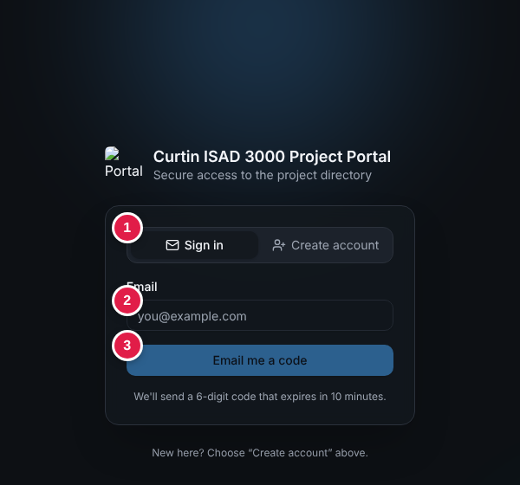
Sign in tab (UAT-AUTH-01, -22)
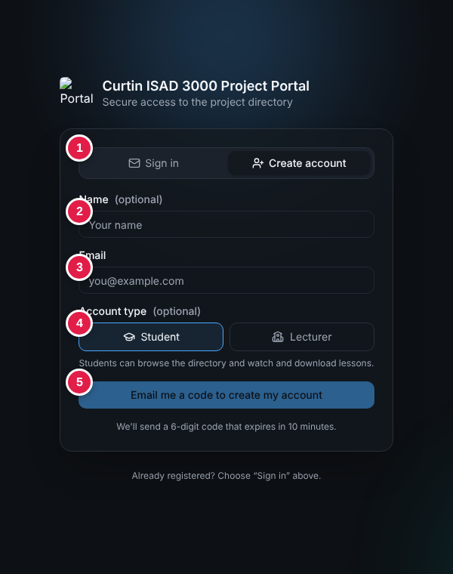
Create account tab (UAT-AUTH-22, -24)
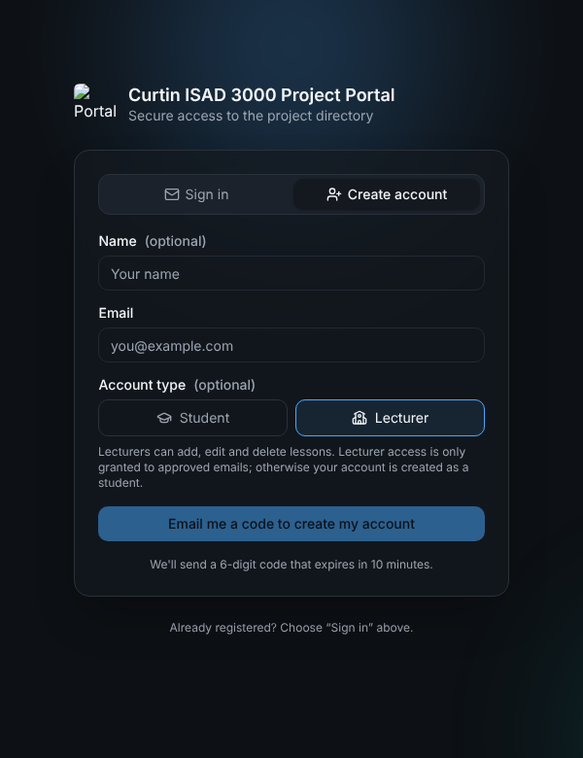
Lecturer account type and note (UAT-AUTH-23)
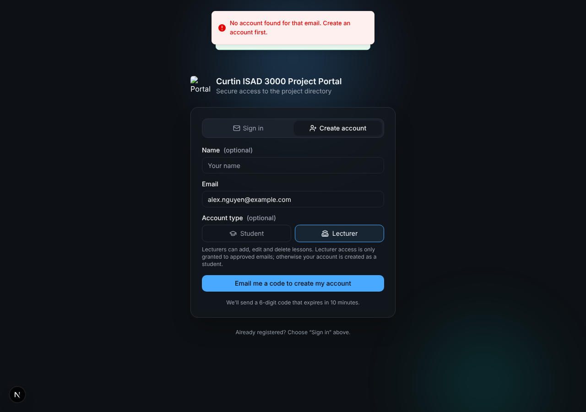
No account found (UAT-AUTH-26)
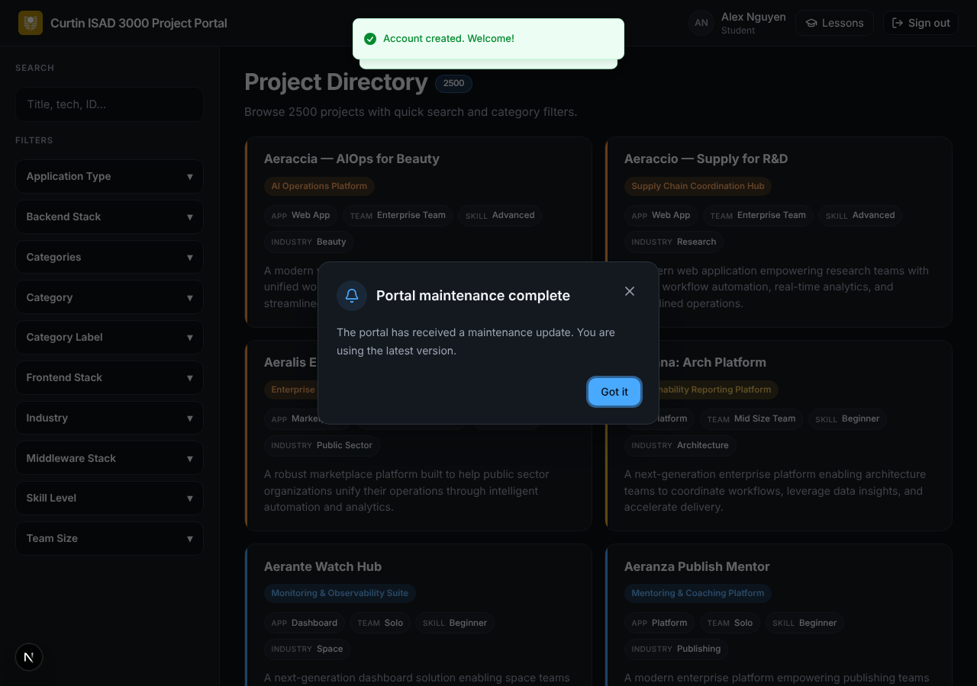
Account created (UAT-AUTH-24)
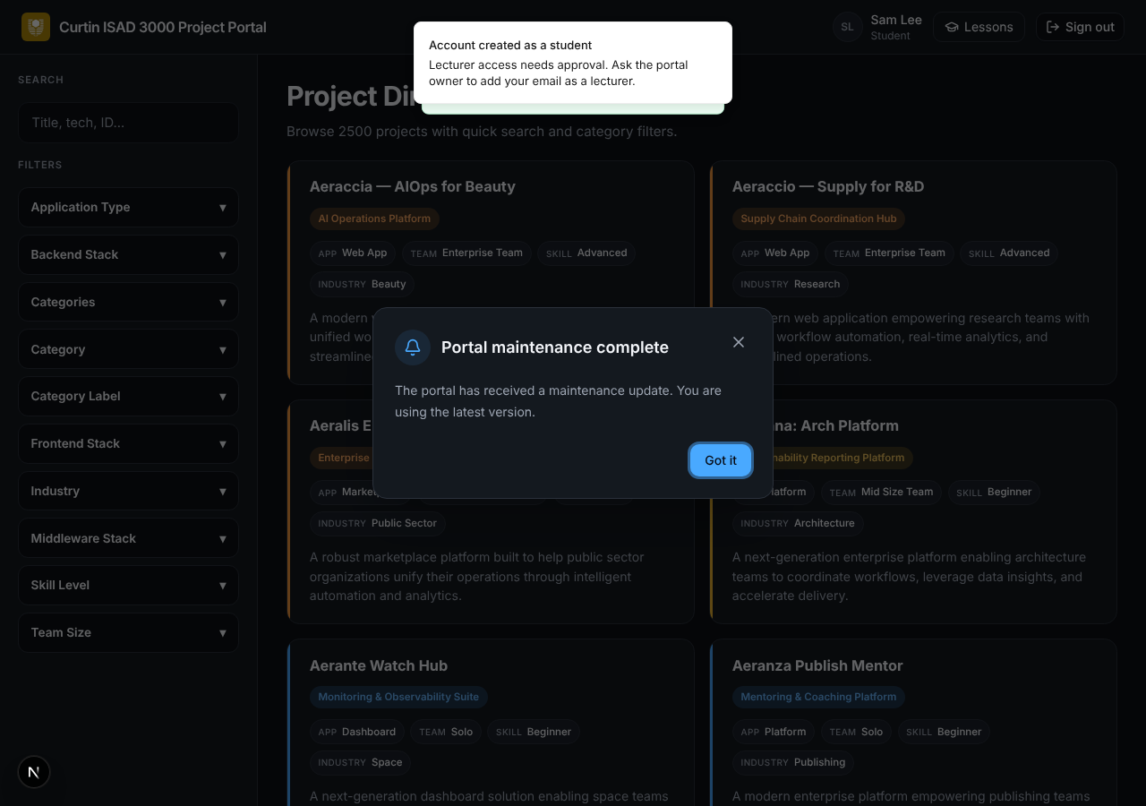
Lecturer request without approval becomes a student (UAT-AUTH-28)
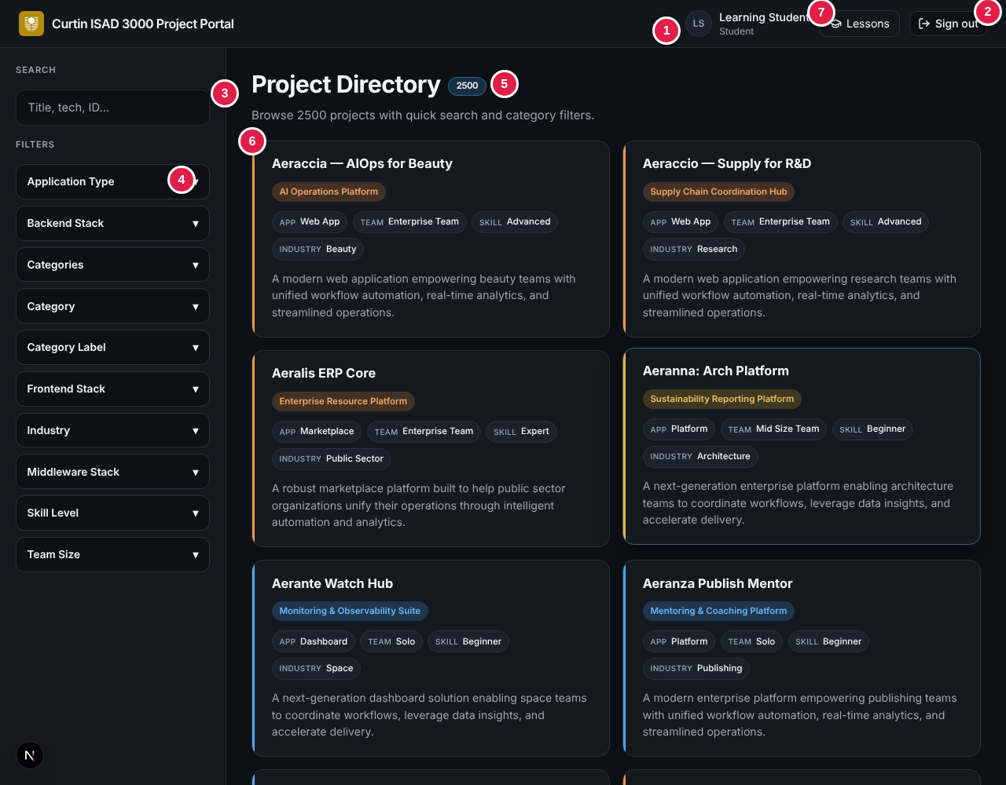
Project directory with Lessons button (UAT-DIR-01, UAT-LESS-01)
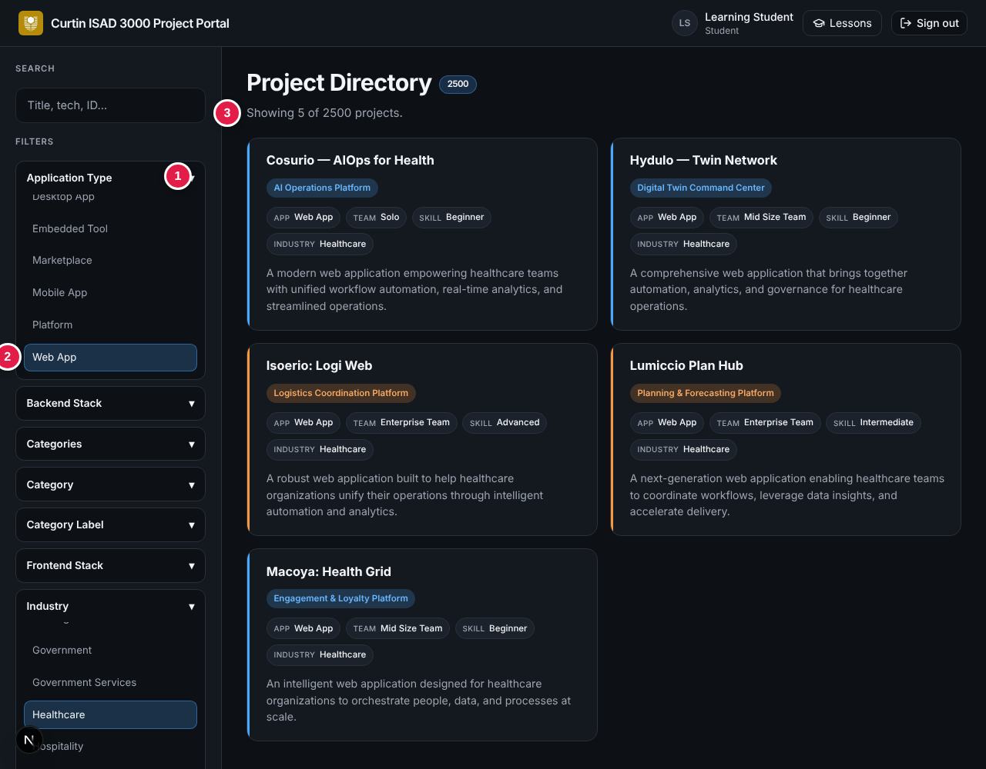
Filters applied (UAT-DIR-12, UAT-DIR-13)
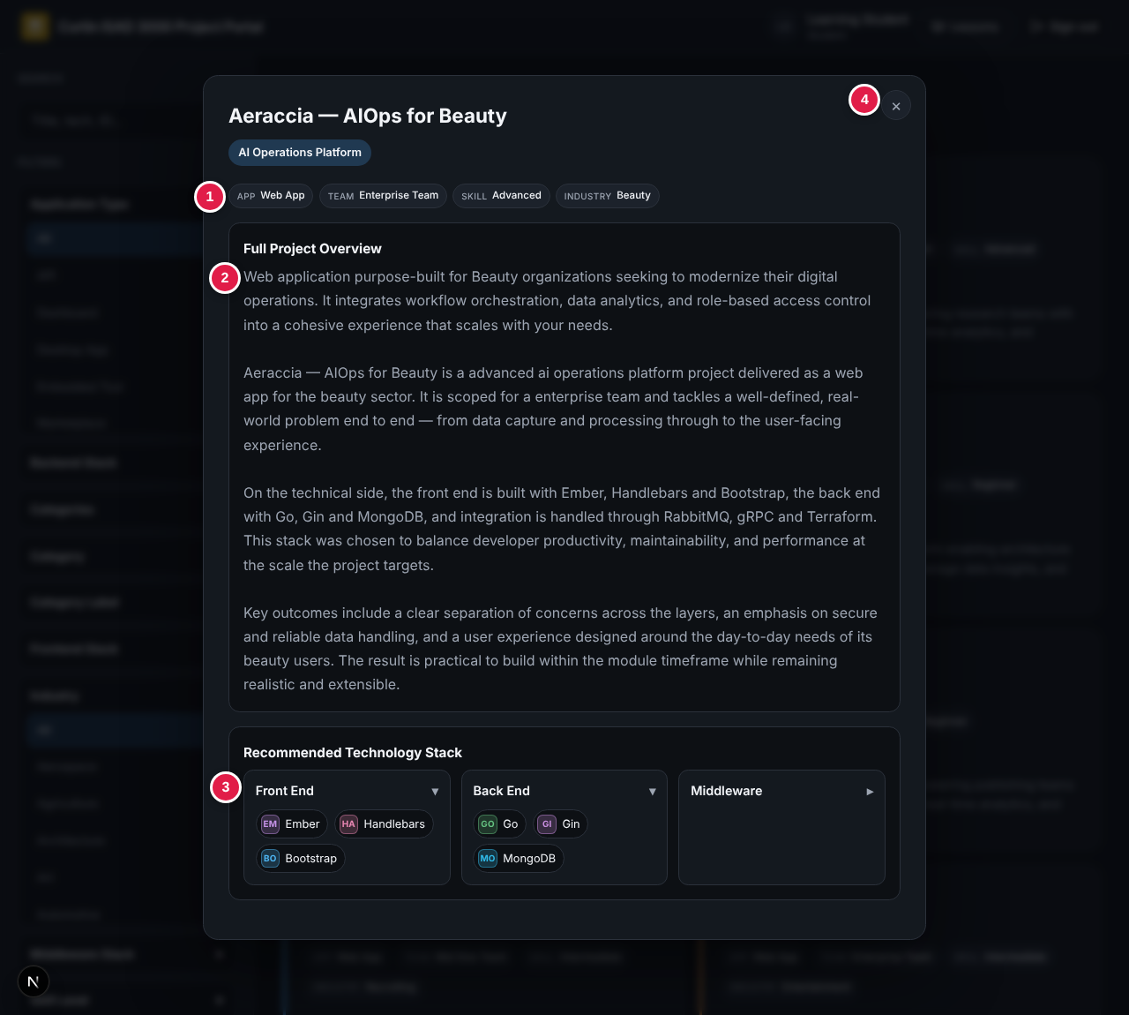
Project detail window (UAT-MOD-01)
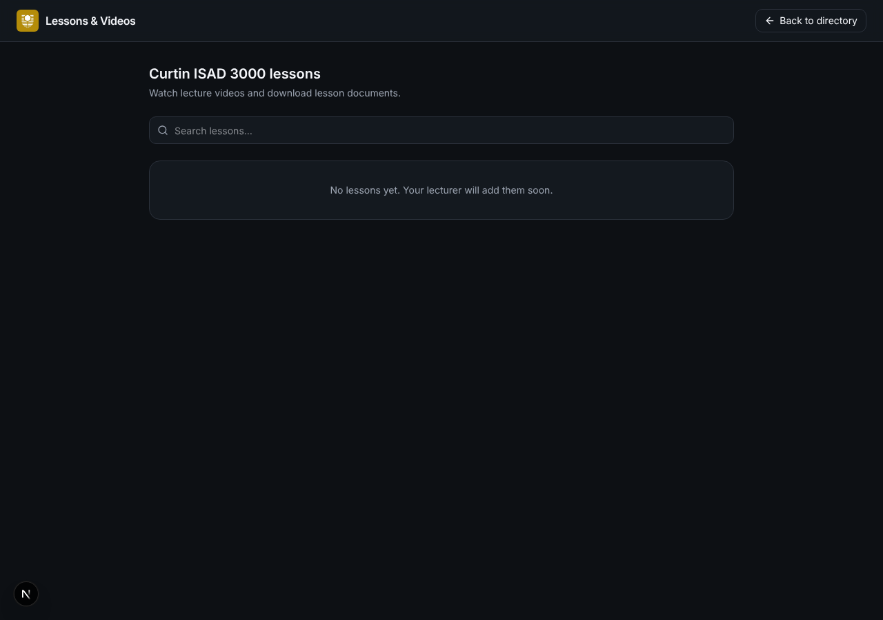
Empty Lessons page, student (UAT-LESS-03)
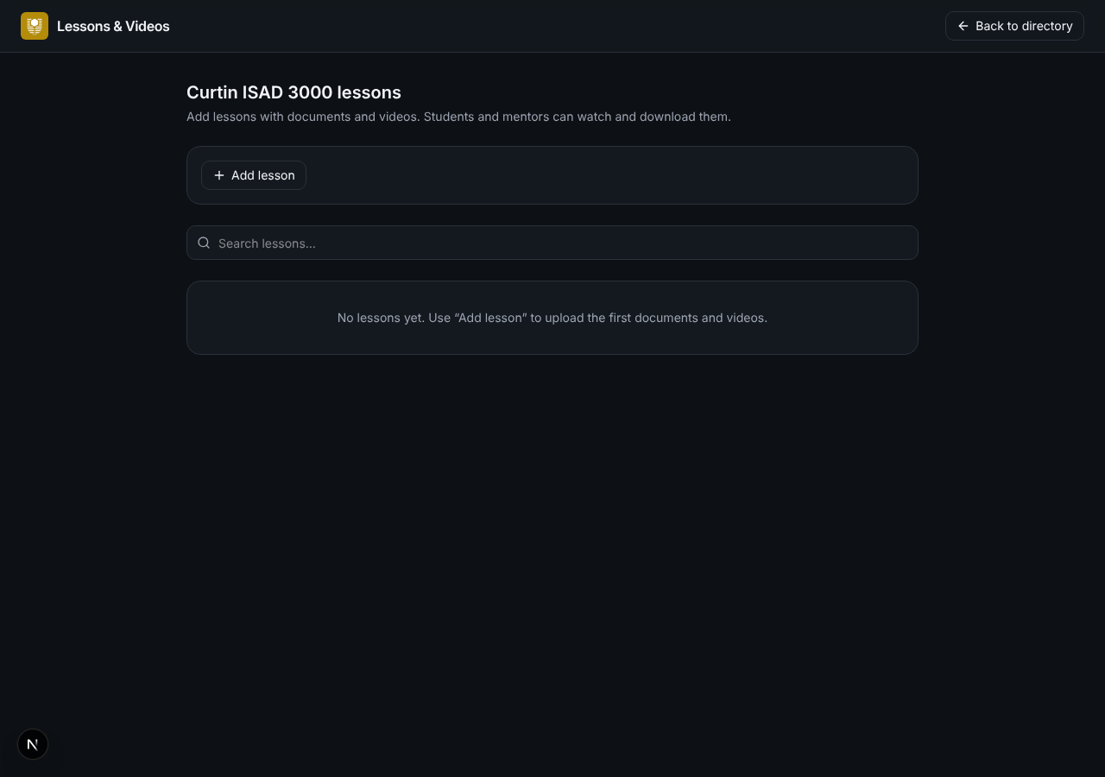
Empty Lessons page, lecturer (UAT-LESS-04)
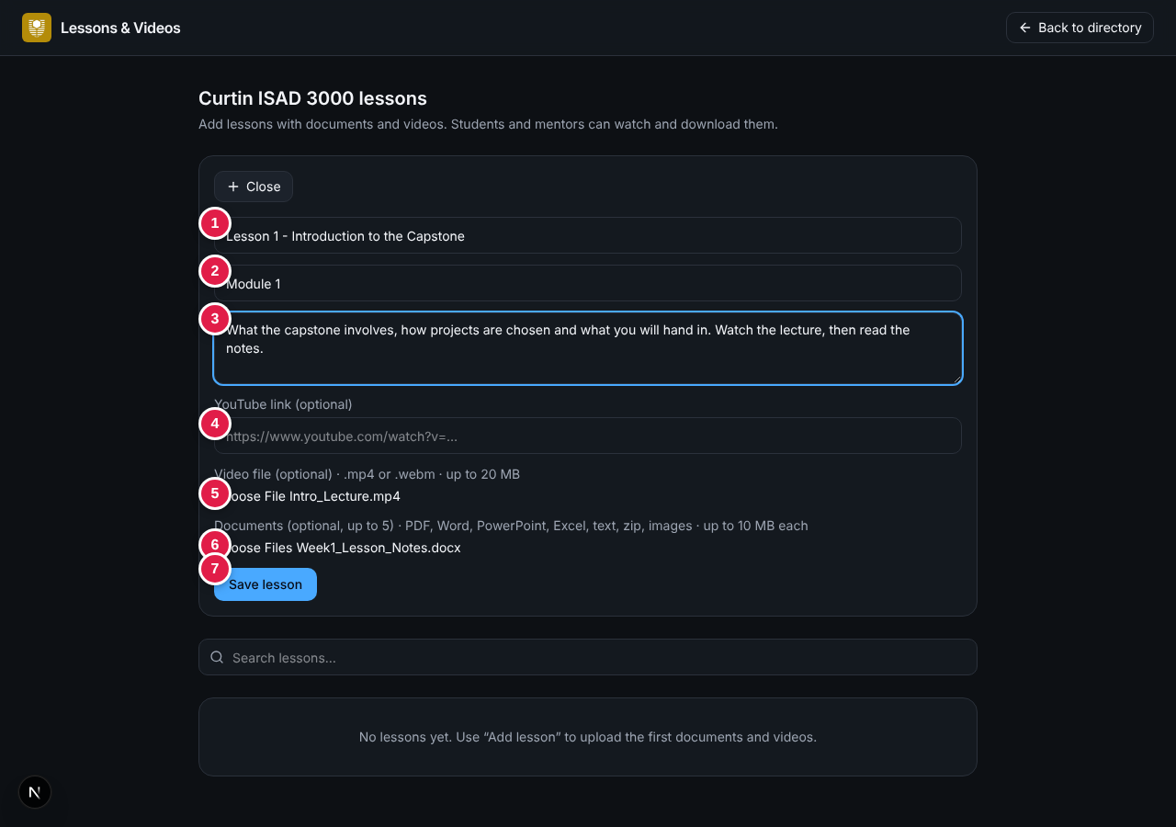
Add lesson form (UAT-LESS-05, -06)
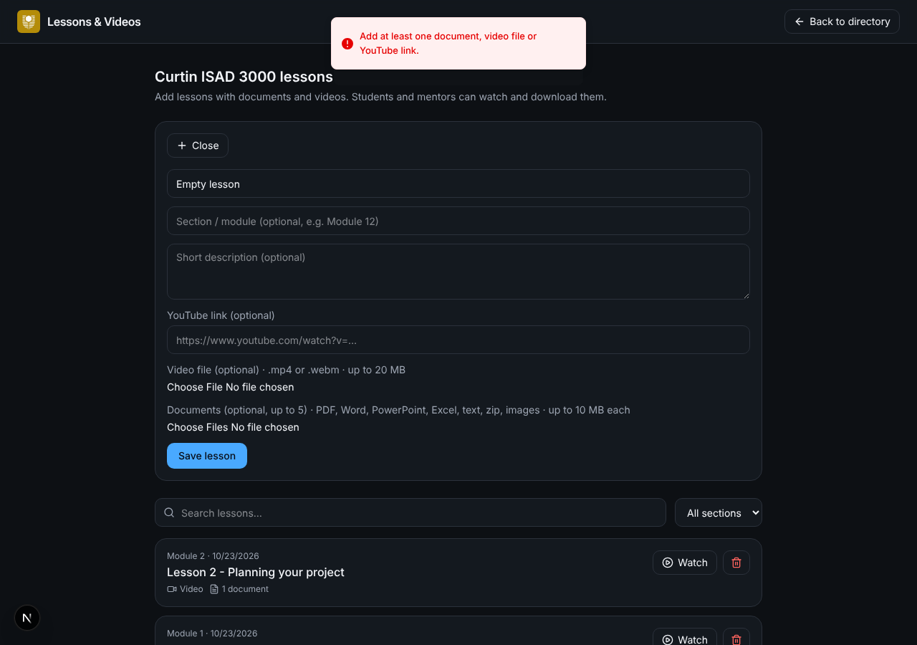
Validation message (UAT-LESS-09)
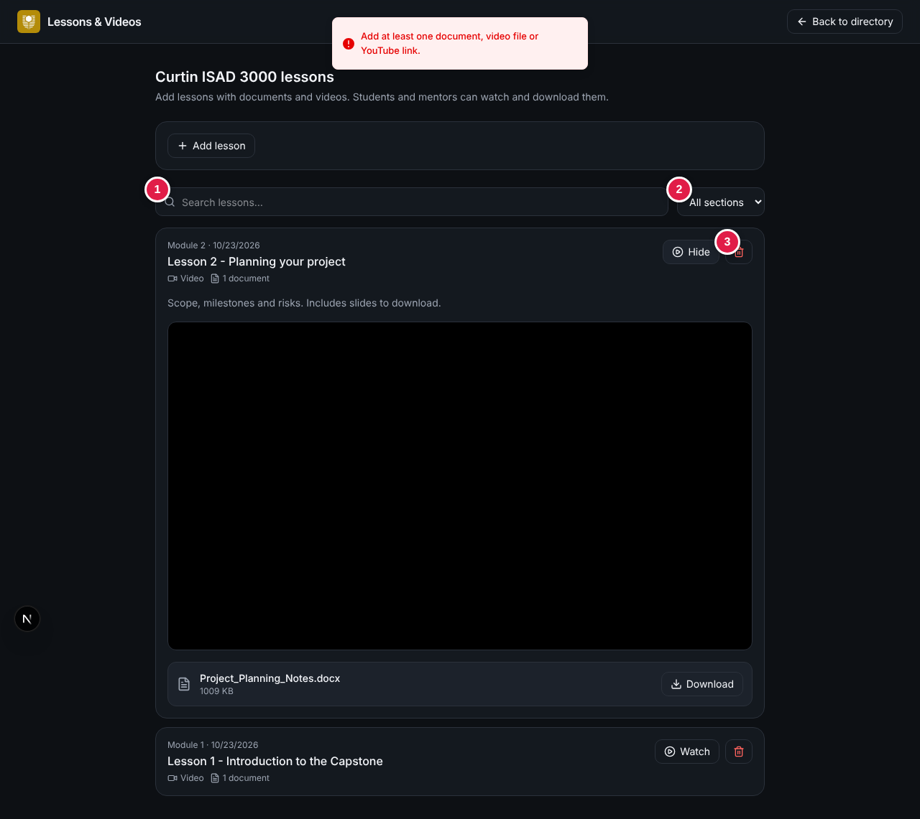
Lecturer view of lessons (UAT-LESS-14, -21)
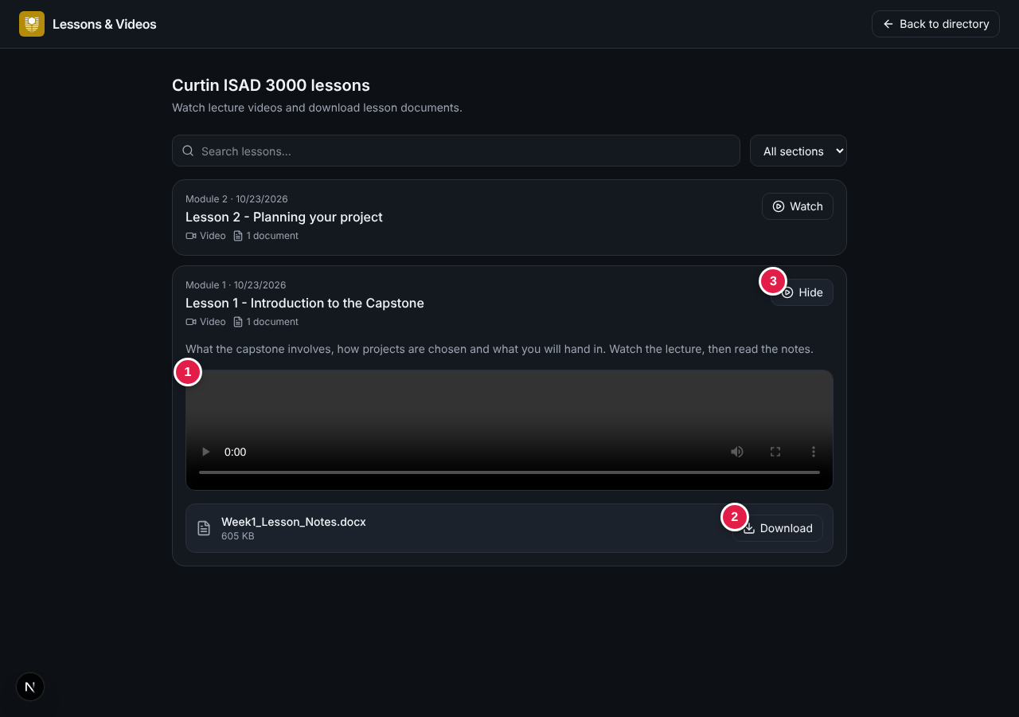
Student view with video and document (UAT-LESS-18, -19)
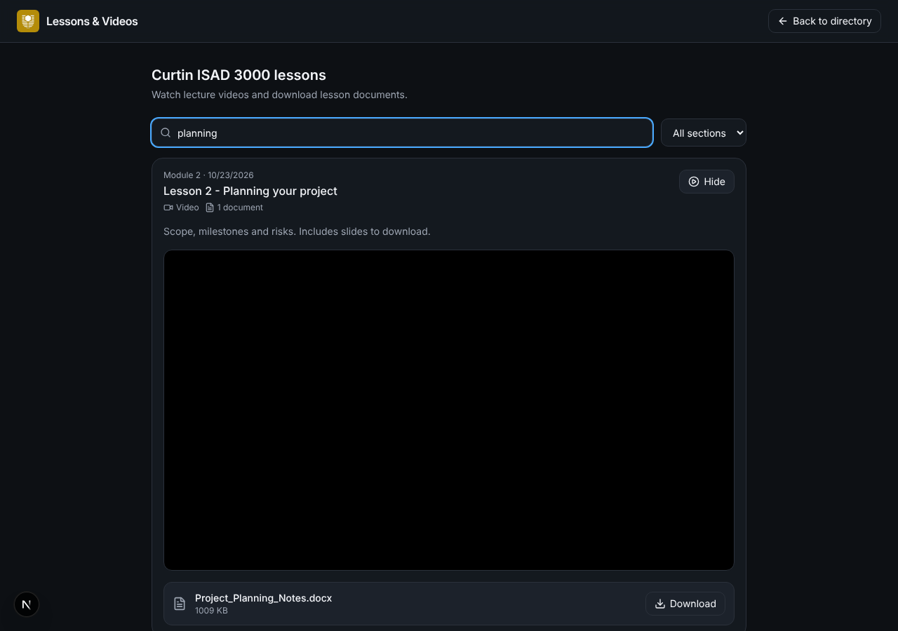
Lesson search (UAT-LESS-15)
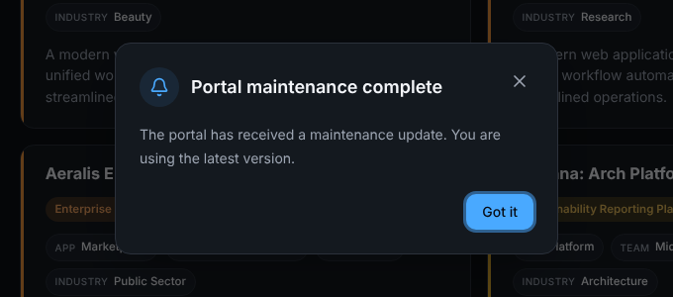
Maintenance notice (UAT-NOTE-01)

4. Test case summary
Module | ID prefix | Title | Cases | High | Medium | Low
AUTH | UAT-AUTH-nn | Sign-in with email code | 30 | 16 | 9 | 5
SESS | UAT-SESS-nn | Session and sign-out | 7 | 4 | 2 | 1
ROLE | UAT-ROLE-nn | Roles and account display | 5 | 2 | 1 | 2
DIR | UAT-DIR-nn | Project directory - browse, search and filter | 19 | 8 | 8 | 3
MOD | UAT-MOD-nn | Project detail window | 6 | 2 | 3 | 1
LESS | UAT-LESS-nn | Lessons & Videos | 27 | 13 | 11 | 3
NOTE | UAT-NOTE-nn | Maintenance notice | 6 | 3 | 2 | 1
PLAT | UAT-PLAT-nn | Platform, security and compatibility | 10 | 4 | 5 | 1
Total |  |  | 110 | 52 | 41 | 17

Detailed test cases follow on landscape pages. Each case ends with a result box to be completed by the tester.

5. Detailed test cases
NOTE
Tick one result for each case, then add initials and date in the Comments cell. Requirement IDs refer to CP-SRS-001.

5.1 Sign-in with email code
Covers the login page, requesting a code, entering a code and every error path of the one-time-code flow.
Test ID | Scenario | Preconditions | Steps | Expected result | Req. | Priority | Result / comments
UAT-AUTH-01 | Login page displays correctly | Signed out. Portal URL known. | 1. Open /login in a new private window.  2. Review the page. | Logo, heading "Curtin ISAD 3000 Project Portal", sub-text "Secure access to the project directory", two tabs Sign in (selected) and Create account, the Email field, the Email me a code button, the hint "We'll send a 6-digit code that expires in 10 minutes." and the footer "New here? Choose “Create account” above." are shown. | FR-04  FR-28 | High | ☐ Pass  ☐ Fail  ☐ Blocked  Init/date:
UAT-AUTH-02 | Unauthenticated visitor is redirected | Signed out (no portal_session cookie). | 1. Open the portal root URL /.  2. Then open /?q=kafka. | Both requests redirect to /login. The second redirect carries ?from=%2F%3Fq%3Dkafka. | FR-01  FR-02 | High | ☐ Pass  ☐ Fail  ☐ Blocked  Init/date:
UAT-AUTH-03 | Request a code with an approved email | Email service (SMTP/Resend) configured; murphy.choy@icloud.com is approved. | 1. On /login type murphy.choy@icloud.com.  2. Click Email me a code. | Button shows a spinner while sending. Toast "If that email has access, a code is on its way." appears. Screen changes to "Enter the 6-digit code sent to <email>." with six empty boxes, "Change email" and "Resend code". | FR-04  FR-06  FR-13 | High | ☐ Pass  ☐ Fail  ☐ Blocked  Init/date:
UAT-AUTH-04 | Button disabled for empty email | On /login. | 1. Leave the Email field empty.  2. Observe the button.  3. Type a character. | Button is disabled while empty and becomes enabled once text is entered. | FR-04 | Medium | ☐ Pass  ☐ Fail  ☐ Blocked  Init/date:
UAT-AUTH-05 | Malformed email is rejected | On /login. | 1. Enter not-an-email (or a@b) and submit.  2. Repeat sending the request directly to /api/auth/request with the same value. | Browser or server rejects the value; the API returns HTTP 400 "Please enter a valid email address." and no code step is shown. | FR-05 | Medium | ☐ Pass  ☐ Fail  ☐ Blocked  Init/date:
UAT-AUTH-06 | Code email content | UAT-AUTH-03 completed. | 1. Open the inbox of the requesting address.  2. Open the newest message. | Subject is "Your Capstone Portal sign-in code: ######". Body shows a 6-digit code in large type and states it expires in 10 minutes and can be ignored if not requested. | FR-10  FR-11 | High | ☐ Pass  ☐ Fail  ☐ Blocked  Init/date:
UAT-AUTH-07 | Sign in with a correct code | A valid code has been received (under 10 minutes old). | 1. Type the six digits into the boxes. | Verification starts automatically on the 6th digit. Toast "Signed in." appears and the browser opens the project directory (or the from page). | FR-14  FR-19  FR-21 | High | ☐ Pass  ☐ Fail  ☐ Blocked  Init/date:
UAT-AUTH-08 | Incorrect code | On the code step. | 1. Enter 000000 (not the issued code). | Toast "Incorrect code. Please try again."; the six boxes are cleared; user stays on the code step. | FR-14  FR-17 | High | ☐ Pass  ☐ Fail  ☐ Blocked  Init/date:
UAT-AUTH-09 | Five-attempt limit | On the code step with an issued code. | 1. Enter five different wrong codes.  2. Enter a sixth code, even the correct one. | Attempts 1-5 show "Incorrect code. Please try again." The sixth attempt shows "Too many attempts. Request a new code." and the correct code is no longer accepted. | FR-17 | High | ☐ Pass  ☐ Fail  ☐ Blocked  Init/date:
UAT-AUTH-10 | Code expires after 10 minutes | A code has been issued. | 1. Wait more than 10 minutes without entering it.  2. Enter the (correct) code. | Toast "No code was requested, or it expired. Request a new one." The code is rejected. | FR-07  FR-18 | High | ☐ Pass  ☐ Fail  ☐ Blocked  Init/date:
UAT-AUTH-11 | Resend cooldown | A code was requested less than 30 seconds ago. | 1. Immediately click Resend code. | Toast "Please wait Ns before requesting another code." (N between 1 and 30). No new email is sent. | FR-08 | Medium | ☐ Pass  ☐ Fail  ☐ Blocked  Init/date:
UAT-AUTH-12 | Resend after cooldown replaces code | A code was requested more than 30 seconds ago. | 1. Click Resend code.  2. Wait for the second email.  3. Enter the FIRST code.  4. Enter the SECOND code. | A new email arrives. The first code is rejected ("Incorrect code. Please try again."); the second code signs the user in. | FR-06  FR-08 | Medium | ☐ Pass  ☐ Fail  ☐ Blocked  Init/date:
UAT-AUTH-13 | Change email link | On the code step. | 1. Click Change email. | The email-entry step is displayed again; code boxes are cleared. | FR-13 | Low | ☐ Pass  ☐ Fail  ☐ Blocked  Init/date:
UAT-AUTH-14 | Code boxes accept digits only | On the code step. | 1. Try typing letters and symbols.  2. Type five digits and pause. | Only digits are accepted. No verification is attempted until all six digits are present. | FR-14  FR-15 | Medium | ☐ Pass  ☐ Fail  ☐ Blocked  Init/date:
UAT-AUTH-15 | Code is bound to the email | Two approved emails, A and B. API client available (browser developer tools, curl or Postman). | 1. Request a code for A and keep the otp_challenge cookie.  2. Send A's correct code together with B's email to /api/auth/verify, using that cookie. | The request fails with "Incorrect code." and no session cookie is set. | FR-16 | High | ☐ Pass  ☐ Fail  ☐ Blocked  Init/date:
UAT-AUTH-16 | Email is case-insensitive | Approved email exists in lower case. | 1. Request a code using the upper/mixed-case form (e.g. Murphy.Choy@iCloud.com).  2. Enter the code received. | Code is issued and sign-in succeeds; the header shows the stored name and role. | FR-20 | Medium | ☐ Pass  ☐ Fail  ☐ Blocked  Init/date:
UAT-AUTH-17 | Unapproved email gives no information | ALLOWED_EMAILS is set and does not contain outsider@example.com. | 1. Request a code for outsider@example.com.  2. Check the inbox.  3. Try any 6-digit code. | Same success toast is shown, but no email arrives. Any code is rejected with "Incorrect code." The response gives no hint whether the account exists. | FR-09 | High | ☐ Pass  ☐ Fail  ☐ Blocked  Init/date:
UAT-AUTH-18 | Return to the originally requested page | Signed out. | 1. Open /?q=kafka.  2. Sign in as murphy.choy@icloud.com. | After sign-in the browser returns to the address that was originally requested (/?q=kafka). | FR-02 | Medium | ☐ Pass  ☐ Fail  ☐ Blocked  Init/date:
UAT-AUTH-19 | Developer echo mode | Non-production build with AUTH_DEV_ECHO=1. | 1. Request a code. | A toast "Dev code: ######" is displayed and no email is sent. In a production build the same setting has no effect. | FR-12 | Low | ☐ Pass  ☐ Fail  ☐ Blocked  Init/date:
UAT-AUTH-20 | Email delivery failure | SMTP/Resend deliberately misconfigured (test environment only). | 1. Request a code. | Toast shows "Email could not be sent. <reason>" (HTTP 502). No code step is displayed and the user can retry. | FR-10 | Medium | ☐ Pass  ☐ Fail  ☐ Blocked  Init/date:
UAT-AUTH-21 | Network failure handling | On /login; browser set to offline. | 1. Request a code. | Toast "Network error. Please try again." and the button becomes active again. | NFR-06  NFR-08 | Low | ☐ Pass  ☐ Fail  ☐ Blocked  Init/date:
UAT-AUTH-22 | Sign in and Create account tabs | Signed out. On /login. | 1. Look at the two tabs.  2. Click Create account.  3. Click Sign in. | Sign in is selected by default. Create account shows Name (optional), Email, Account type (optional: Student selected, Lecturer) and the button "Email me a code to create my account"; the footer changes to "Already registered? Choose “Sign in” above." Switching back restores the sign-in form. | FR-28  FR-29 | High | ☐ Pass  ☐ Fail  ☐ Blocked  Init/date:
UAT-AUTH-23 | Account type notes | On the Create account tab. | 1. Look at the note under Account type.  2. Click Lecturer. | With Student: "Students can browse the directory and watch and download lessons." With Lecturer: "Lecturers can add, edit and delete lessons. Lecturer access is only granted to approved emails; otherwise your account is created as a student." | FR-29 | Medium | ☐ Pass  ☐ Fail  ☐ Blocked  Init/date:
UAT-AUTH-24 | Create a student account | Approved email new.student@example.com (no account) and mailbox access. | 1. On Create account enter name "Alex Nguyen" and the email; keep Student.  2. Click Email me a code to create my account.  3. Check the text on the code step, then enter the code. | The code step ends "to create your account." After the sixth digit the toast "Account created. Welcome!" appears and the directory opens; the header shows "Alex Nguyen" and the role "Student". | FR-29  FR-32  FR-26 | High | ☐ Pass  ☐ Fail  ☐ Blocked  Init/date:
UAT-AUTH-25 | Name is optional | Approved email without an account. | 1. Create an account leaving Name empty. | The account is created and the header shows the part of the email before the @ as the name. | FR-32 | Low | ☐ Pass  ☐ Fail  ☐ Blocked  Init/date:
UAT-AUTH-26 | Sign in without an account | Approved email alex.nguyen2@example.com with no account. | 1. On Sign in request a code and enter it. | Toast "No account found for that email. Create an account first." The page switches to Create account with the email kept. No session is created. | FR-30 | High | ☐ Pass  ☐ Fail  ☐ Blocked  Init/date:
UAT-AUTH-27 | Create account for an existing email | Account student@portal.com exists. | 1. On Create account request a code for that email and enter it. | Toast "An account with this email already exists. Sign in instead." The page switches to Sign in. The existing account is unchanged. | FR-31 | High | ☐ Pass  ☐ Fail  ☐ Blocked  Init/date:
UAT-AUTH-28 | Unapproved lecturer request becomes a student | Approved email sam.lee@example.com with no account; the email is not a registered lecturer. | 1. On Create account choose Lecturer, enter the email and name, request a code and enter it. | The account is created as a Student. A notice "Account created as a student" with "Lecturer access needs approval. Ask the portal owner to add your email as a lecturer." is shown; the header role is Student and the Lessons page has no Add lesson button. | FR-32  FR-62 | High | ☐ Pass  ☐ Fail  ☐ Blocked  Init/date:
UAT-AUTH-29 | Registered lecturer signs in with lecturer rights | Lecturer murphy.choy@icloud.com exists. | 1. On Sign in request a code for the email and enter it. | Sign-in succeeds. The header shows "Murphy Choy" and the role "Lecturer"; no role has to be chosen. The Lessons page shows Add lesson. | FR-26  FR-57 | High | ☐ Pass  ☐ Fail  ☐ Blocked  Init/date:
UAT-AUTH-30 | Account creation when the database is read-only | Test hosting without a writable database. | 1. Create an account and enter the code. | Error "Could not save the account (database is read-only). Set DATABASE_URL on the server." No session is created. | FR-33 | Low | ☐ Pass  ☐ Fail  ☐ Blocked  Init/date:

5.2 Session and sign-out
Verifies cookie properties, session lifetime, tampering resistance and sign-out.
Test ID | Scenario | Preconditions | Steps | Expected result | Req. | Priority | Result / comments
UAT-SESS-01 | Session cookie attributes | Signed in on the production (HTTPS) site. | 1. Open browser developer tools > Application > Cookies.  2. Inspect portal_session. | Cookie is HttpOnly, SameSite=Lax, Path=/, Secure, and expires about 8 hours after sign-in. It cannot be read by document.cookie. | FR-22  NFR-04 | High | ☐ Pass  ☐ Fail  ☐ Blocked  Init/date:
UAT-SESS-02 | Session persists across reload and tabs | Signed in. | 1. Refresh the page.  2. Open the portal URL in a second tab. | User remains signed in in both tabs without a new code. | FR-21 | Medium | ☐ Pass  ☐ Fail  ☐ Blocked  Init/date:
UAT-SESS-03 | Sign out | Signed in. | 1. Click Sign out in the header.  2. Press the browser Back button. | User is redirected to /login. Cookie portal_session is removed. Going Back does not display the directory (redirects to /login). | FR-24 | High | ☐ Pass  ☐ Fail  ☐ Blocked  Init/date:
UAT-SESS-04 | Session expiry | Signed in; time can be advanced (or the cookie edited to an expired token). | 1. Wait 8 hours or use an expired token.  2. Refresh the page. | User is redirected to /login; sign-in is required again. | FR-03  FR-21 | Medium | ☐ Pass  ☐ Fail  ☐ Blocked  Init/date:
UAT-SESS-05 | Tampered cookie is rejected | Signed in as a Student. | 1. In developer tools, change the middle part of the portal_session value (e.g. alter the payload role to Lecturer).  2. Refresh. | The signature check fails; the user is redirected to /login. Role cannot be elevated by editing the cookie. | FR-03  NFR-05 | High | ☐ Pass  ☐ Fail  ☐ Blocked  Init/date:
UAT-SESS-06 | API requires authentication | Signed out. | 1. Request /api/projects without a cookie (browser, curl or Postman). | No data is returned: the request is redirected to /login (HTTP 307/308). | FR-01  NFR-05 | High | ☐ Pass  ☐ Fail  ☐ Blocked  Init/date:
UAT-SESS-07 | Missing SESSION_SECRET is reported clearly | Test environment without SESSION_SECRET. | 1. Request a code. | A visible error "Server error: SESSION_SECRET is missing or too short..." is shown instead of a blank failure. | FR-23 | Low | ☐ Pass  ☐ Fail  ☐ Blocked  Init/date:

5.3 Roles and account display
Confirms that the signed-in name and role are shown correctly for each account.
Test ID | Scenario | Preconditions | Steps | Expected result | Req. | Priority | Result / comments
UAT-ROLE-01 | Student header | Signed in as student@portal.com (Student). | 1. Look at the header. | Initials avatar, name "Learning Student" and role "Student" are shown, together with the Sign out button. | FR-26  FR-34 | High | ☐ Pass  ☐ Fail  ☐ Blocked  Init/date:
UAT-ROLE-02 | Lecturer header | Signed in as murphy.choy@icloud.com (registered Lecturer). | 1. Look at the header. | Avatar "MC", name "Murphy Choy", role "Lecturer" and Sign out are shown. | FR-26  FR-34 | High | ☐ Pass  ☐ Fail  ☐ Blocked  Init/date:
UAT-ROLE-03 | Approved email without an account | Approved email with no account (not in the user list, never registered). | 1. On the Sign in tab request a code for that email and enter it. | Sign-in is refused with "No account found for that email. Create an account first." and the page switches to the Create account tab. | FR-27  FR-30 | Medium | ☐ Pass  ☐ Fail  ☐ Blocked  Init/date:
UAT-ROLE-04 | Avatar initials | Signed in as "Dang Tran" and as "Course Mentor". | 1. Compare the avatar circles. | Initials are "DT" and "CM" respectively. | FR-34 | Low | ☐ Pass  ☐ Fail  ☐ Blocked  Init/date:
UAT-ROLE-05 | Header responsiveness | Signed in. | 1. Narrow the window below 640 px. | Name/role block is hidden on small screens; the Sign out button remains usable. | NFR-09 | Low | ☐ Pass  ☐ Fail  ☐ Blocked  Init/date:

5.4 Project directory - browse, search and filter
Validates the main user-facing function against the bundled dataset of 2,500 projects. Expected counts below are for the bundled dataset.
Test ID | Scenario | Preconditions | Steps | Expected result | Req. | Priority | Result / comments
UAT-DIR-01 | Directory loads | Signed in. | 1. Open /. | Heading "Project Directory" with count chip 2500. Subtitle reads "Browse 2500 projects with quick search and category filters." Project cards fill the page; sidebar shows Search and Filters. | FR-35 | High | ☐ Pass  ☐ Fail  ☐ Blocked  Init/date:
UAT-DIR-02 | Project card content | Directory loaded. | 1. Inspect the first card (PRJ-0001 "Hypesco - AIOps for Edu" appears among results). | Card shows title, a category label (e.g. "AI Operations Platform"), pills App / Team / Skill / Industry and a one-sentence description. | FR-36 | High | ☐ Pass  ☐ Fail  ☐ Blocked  Init/date:
UAT-DIR-03 | Search by title word | Directory loaded. | 1. Type Hypesco in the Search box. | List updates as you type; subtitle becomes "Showing N of 2500 projects." and the matching "Hypesco" projects appear at the top. | FR-37  FR-39 | High | ☐ Pass  ☐ Fail  ☐ Blocked  Init/date:
UAT-DIR-04 | Search by project ID | Directory loaded. | 1. Type PRJ-0001. | Subtitle reads "Showing 1 of 2500 projects." and only PRJ-0001 is listed. | FR-37 | High | ☐ Pass  ☐ Fail  ☐ Blocked  Init/date:
UAT-DIR-05 | Search by technology | Directory loaded. | 1. Type Kafka. | Subtitle reads "Showing 417 of 2500 projects."; each result lists Kafka in its middleware stack. | FR-37 | High | ☐ Pass  ☐ Fail  ☐ Blocked  Init/date:
UAT-DIR-06 | Case and accent insensitive | Directory loaded. | 1. Search KAFKA, then kafka. | Both searches give the same 417 results. | FR-38 | Medium | ☐ Pass  ☐ Fail  ☐ Blocked  Init/date:
UAT-DIR-07 | Multi-term search ranking | Directory loaded. | 1. Type react healthcare. | Projects matching both words are ranked above projects matching only one. Total shown is greater than the count of projects matching both. | FR-38  FR-43 | Medium | ☐ Pass  ☐ Fail  ☐ Blocked  Init/date:
UAT-DIR-08 | No results | Directory loaded. | 1. Type zzzzqqq. | Subtitle reads "Showing 0 of 2500 projects." and no cards are visible; no error appears. | FR-39 | Medium | ☐ Pass  ☐ Fail  ☐ Blocked  Init/date:
UAT-DIR-09 | Clearing search restores list | A search is active. | 1. Delete all text in the Search box. | All 2,500 projects are listed again. | FR-39 | Medium | ☐ Pass  ☐ Fail  ☐ Blocked  Init/date:
UAT-DIR-10 | Filter groups generated from data | Directory loaded. | 1. Review the Filters panel. | Ten alphabetical groups are present: Application Type, Backend Stack, Categories, Category, Category Label, Frontend Stack, Industry, Middleware Stack, Skill Level, Team Size. Free-text fields (ID, Title, Shortdesc, Fulldesc) do not appear as filters. | FR-40  FR-41 | High | ☐ Pass  ☐ Fail  ☐ Blocked  Init/date:
UAT-DIR-11 | Expand and collapse a filter group | Directory loaded. | 1. Click Skill Level.  2. Click it again. | The group opens to show chips All, Advanced, Beginner, Expert, Intermediate; clicking again collapses it. | FR-41 | Medium | ☐ Pass  ☐ Fail  ☐ Blocked  Init/date:
UAT-DIR-12 | Apply one filter | Skill Level group open. | 1. Click Expert. | The Expert chip is highlighted; subtitle reads "Showing 250 of 2500 projects." | FR-41  FR-42 | High | ☐ Pass  ☐ Fail  ☐ Blocked  Init/date:
UAT-DIR-13 | Combine two filters (AND) | Directory loaded. | 1. Choose Application Type = Web App.  2. Choose Industry = Healthcare. | Count falls from 313 (Web App only) to 5; every result shows App "Web App" and Industry "Healthcare". | FR-42 | High | ☐ Pass  ☐ Fail  ☐ Blocked  Init/date:
UAT-DIR-14 | Combine filter and search | Application Type = Web App is active. | 1. Type Kafka in Search. | Only Web App projects that mention Kafka are shown; count is lower than both individual counts. | FR-42 | Medium | ☐ Pass  ☐ Fail  ☐ Blocked  Init/date:
UAT-DIR-15 | Reset a filter with All | One or more filters active. | 1. In the group, click the All chip. | That group's filter is removed and the count updates; other groups remain active. | FR-41 | Medium | ☐ Pass  ☐ Fail  ☐ Blocked  Init/date:
UAT-DIR-16 | Filters with no match | Directory loaded. | 1. Choose Skill Level = Expert and Team Size = Solo. | "Showing 0 of 2500 projects." (no Expert project is Solo in the bundled data). The user can recover by choosing All. | FR-42 | Low | ☐ Pass  ☐ Fail  ☐ Blocked  Init/date:
UAT-DIR-17 | Result order | Directory loaded. | 1. Apply a filter such as Industry = Education.  2. Read titles from top to bottom. | Matches are listed alphabetically by title (equal relevance), with non-matching cards hidden. | FR-43 | Low | ☐ Pass  ☐ Fail  ☐ Blocked  Init/date:
UAT-DIR-18 | Responsiveness of filtering | Directory loaded on a standard laptop. | 1. Type quickly in Search.  2. Switch several filters in succession. | The list updates without noticeable lag (under about 1 second) and the page does not freeze. | NFR-01 | Medium | ☐ Pass  ☐ Fail  ☐ Blocked  Init/date:
UAT-DIR-19 | Directory data failure message | Test environment where /api/projects fails. | 1. Load /. | The subtitle shows "Unable to load project data." and the page does not crash. | NFR-06 | Low | ☐ Pass  ☐ Fail  ☐ Blocked  Init/date:

5.5 Project detail window
Checks the detail pop-up opened from a project card.
Test ID | Scenario | Preconditions | Steps | Expected result | Req. | Priority | Result / comments
UAT-MOD-01 | Open project details | Directory loaded. | 1. Click any project card. | A window opens with the title, coloured category label, metadata pills, "Full Project Overview" (several paragraphs) and "Recommended Technology Stack". | FR-44 | High | ☐ Pass  ☐ Fail  ☐ Blocked  Init/date:
UAT-MOD-02 | Overview content | Detail window open. | 1. Read the overview. | First paragraph is the project's own description; following paragraphs describe the project type, the technology choices and the expected outcomes, using the project's industry, application type, team size and skill level. | FR-44 | Medium | ☐ Pass  ☐ Fail  ☐ Blocked  Init/date:
UAT-MOD-03 | Technology stack sections | Detail window open. | 1. Click Front End, Back End and Middleware in turn. | Each section is collapsed by default, expands to coloured chips with two-letter badges, and the arrow flips between ▸ and ▾. | FR-45 | Medium | ☐ Pass  ☐ Fail  ☐ Blocked  Init/date:
UAT-MOD-04 | Close with × | Detail window open. | 1. Click the × button. | The window closes; scroll position and filters are unchanged. | FR-46 | High | ☐ Pass  ☐ Fail  ☐ Blocked  Init/date:
UAT-MOD-05 | Close by clicking outside | Detail window open. | 1. Click the dark area outside the window. | The window closes. Clicking inside the window does not close it. | FR-46 | Medium | ☐ Pass  ☐ Fail  ☐ Blocked  Init/date:
UAT-MOD-06 | Different project, fresh content | Detail window closed. | 1. Open project A, close, open project B. | Window shows only project B's data; stacks start collapsed again. | FR-44 | Low | ☐ Pass  ☐ Fail  ☐ Blocked  Init/date:

5.6 Lessons & Videos
Covers the Lessons page for students and the lesson management tools for lecturers: adding lessons with documents, video files or YouTube links, validation rules, viewing, downloading and deleting.
Test ID | Scenario | Preconditions | Steps | Expected result | Req. | Priority | Result / comments
UAT-LESS-01 | Lessons button and page (student) | Signed in as student@portal.com (Student). | 1. Look at the header.  2. Click Lessons. | A Lessons button is shown next to Sign out. The page "Curtin ISAD 3000 lessons" opens with the text "Watch lecture videos and download lesson documents." and a search box. There is no Add lesson button. | FR-48  FR-50 | High | ☐ Pass  ☐ Fail  ☐ Blocked  Init/date:
UAT-LESS-02 | Lessons require sign-in | Signed out. | 1. Open /lessons.  2. Open /api/lessons.  3. Open /api/lessons/files/any-id. | All three requests redirect to /login; no lesson data or file is returned. | FR-49  FR-64  NFR-15 | High | ☐ Pass  ☐ Fail  ☐ Blocked  Init/date:
UAT-LESS-03 | Empty state (student) | No lessons have been added. | 1. Open Lessons as a Student. | The message "No lessons yet. Your lecturer will add them soon." is shown. | FR-55 | Medium | ☐ Pass  ☐ Fail  ☐ Blocked  Init/date:
UAT-LESS-04 | Empty state and Add lesson (lecturer) | Signed in as murphy.choy@icloud.com (Lecturer); no lessons exist. | 1. Open Lessons. | Text reads "Add lessons with documents and videos. Students and mentors can watch and download them." An Add lesson button is shown with the message "No lessons yet. Use “Add lesson” to upload the first documents and videos." | FR-50  FR-55  FR-57 | High | ☐ Pass  ☐ Fail  ☐ Blocked  Init/date:
UAT-LESS-05 | Open the Add lesson form | Lecturer on the Lessons page. | 1. Click Add lesson. | A form opens with Lesson title, Section / module, Short description, YouTube link, Video file (.mp4 or .webm, up to 20 MB) and Documents (up to 5, 10 MB each) fields and a Save lesson button. The button label becomes Close. | FR-57 | High | ☐ Pass  ☐ Fail  ☐ Blocked  Init/date:
UAT-LESS-06 | Add a lesson with a video file and a document | Form open. A small .mp4 and a .docx file are available. | 1. Enter title "Lesson 1 - Introduction", section "Module 1" and a description.  2. Choose the .mp4 as Video file and the .docx as Documents.  3. Click Save lesson. | The button shows "Uploading..." then toast "Lesson added." appears, the form closes and the new lesson is listed with a Video icon and "1 document". | FR-57  FR-60  FR-61 | High | ☐ Pass  ☐ Fail  ☐ Blocked  Init/date:
UAT-LESS-07 | Add a lesson with a YouTube link | Form open. | 1. Enter a title.  2. Paste a YouTube link such as https://www.youtube.com/watch?v=aqz-KE-bpKQ.  3. Attach one document and save. | Toast "Lesson added." The lesson appears at the top of the list (newest first) with a Video icon. | FR-51  FR-59  FR-61 | High | ☐ Pass  ☐ Fail  ☐ Blocked  Init/date:
UAT-LESS-08 | Title is required | Form open. | 1. Leave the title empty.  2. Click Save lesson. | The browser asks for the title and nothing is saved. (Sent directly to the API, the response is "Please enter a title.") | FR-58 | Medium | ☐ Pass  ☐ Fail  ☐ Blocked  Init/date:
UAT-LESS-09 | At least one item is required | Form open. | 1. Enter only a title.  2. Click Save lesson. | Toast "Add at least one document, video file or YouTube link." No lesson is added. | FR-58 | High | ☐ Pass  ☐ Fail  ☐ Blocked  Init/date:
UAT-LESS-10 | Invalid YouTube link | Form open. | 1. Enter a title and the link https://example.com/video.  2. Save. | Toast "That does not look like a YouTube link." No lesson is added. | FR-59 | Medium | ☐ Pass  ☐ Fail  ☐ Blocked  Init/date:
UAT-LESS-11 | Too many documents | Form open; six small files available. | 1. Select six files in Documents.  2. Save. | Toast "You can attach up to 5 documents per lesson." No lesson is added. | FR-60  NFR-18 | Medium | ☐ Pass  ☐ Fail  ☐ Blocked  Init/date:
UAT-LESS-12 | Disallowed document type | Form open; an .exe file available. | 1. Choose the .exe file (select All files in the file dialog).  2. Save. | Toast "Document type .exe is not allowed." No lesson is added. | FR-60 | Medium | ☐ Pass  ☐ Fail  ☐ Blocked  Init/date:
UAT-LESS-13 | File too large | Form open; a video over 20 MB (or a document over 10 MB). | 1. Choose the large file.  2. Save. | For a video: "The video is larger than 20 MB. Upload it to YouTube and paste the link instead." For a document: "<name> is larger than 10 MB." Nothing is saved. | FR-60  NFR-18 | Medium | ☐ Pass  ☐ Fail  ☐ Blocked  Init/date:
UAT-LESS-14 | Lesson cards and ordering | At least two lessons exist. | 1. Look at the list. | Newest lesson is first. Each card shows "section - date", the title, a Video icon (if any) and "N document(s)". | FR-51 | Medium | ☐ Pass  ☐ Fail  ☐ Blocked  Init/date:
UAT-LESS-15 | Search lessons (student) | Signed in as a Student; lessons "Lesson 1 - Introduction" and "Lesson 2 - Planning" exist. | 1. Type planning in Search lessons.... | Only lessons whose title, description or section contain the word are shown (not case sensitive). Clearing the box shows all lessons. | FR-52 | High | ☐ Pass  ☐ Fail  ☐ Blocked  Init/date:
UAT-LESS-16 | Filter by section | Lessons exist with sections "Module 1" and "Module 2". | 1. Open the section list and choose Module 1. | The list shows only Module 1 lessons. Choose All sections to restore. | FR-53 | Medium | ☐ Pass  ☐ Fail  ☐ Blocked  Init/date:
UAT-LESS-17 | Open a lesson with a YouTube video | A lesson with a YouTube link exists; internet access. | 1. Click Watch. | The card expands with the description, an embedded YouTube player and the document card. The button changes to Hide. | FR-54 | High | ☐ Pass  ☐ Fail  ☐ Blocked  Init/date:
UAT-LESS-18 | Play an uploaded video | A lesson with an uploaded video exists. | 1. Click Watch.  2. Press play, then drag the progress bar. | The video plays inside the page and can be moved forward and back (seeking works). | FR-54  FR-64 | High | ☐ Pass  ☐ Fail  ☐ Blocked  Init/date:
UAT-LESS-19 | Download a document | An opened lesson has a document. | 1. Click Download.  2. Open the downloaded file. | The file downloads with its original name and opens without errors; the card shows the file name and size (for example "605 KB"). | FR-54  FR-64 | High | ☐ Pass  ☐ Fail  ☐ Blocked  Init/date:
UAT-LESS-20 | Hide a lesson | A lesson is open. | 1. Click Hide. | The card collapses to its heading and a Watch button. | FR-54 | Low | ☐ Pass  ☐ Fail  ☐ Blocked  Init/date:
UAT-LESS-21 | Delete a lesson | Lecturer on the Lessons page with a test lesson. | 1. Click the trash button on the lesson.  2. Accept the confirmation "Delete "<title>" and its files?" | Toast "Lesson deleted." The lesson disappears; as a student the lesson is no longer listed and its files return "File not found." | FR-63 | High | ☐ Pass  ☐ Fail  ☐ Blocked  Init/date:
UAT-LESS-22 | Cancel a delete | Lecturer on the Lessons page. | 1. Click the trash button.  2. Cancel the confirmation. | Nothing is deleted. | FR-63 | Medium | ☐ Pass  ☐ Fail  ☐ Blocked  Init/date:
UAT-LESS-23 | Students cannot manage lessons | Signed in as a Student. API client available. | 1. Send POST /api/lessons (with a title and YouTube link) and DELETE /api/lessons/<id> using the student session cookie. | Both return HTTP 403 "Lecturer access required." No data changes. The Lessons page for the student shows no Add lesson or trash buttons. | FR-62  NFR-15 | High | ☐ Pass  ☐ Fail  ☐ Blocked  Init/date:
UAT-LESS-24 | Lessons persist | A lesson was added. | 1. Reload the page.  2. Sign out, sign in on another browser or device as a Student. | The lesson and its files are still available. | FR-61 | Medium | ☐ Pass  ☐ Fail  ☐ Blocked  Init/date:
UAT-LESS-25 | Hosted database not writable | Test hosting without a writable database. | 1. Try to add a lesson. | An error toast shows the message plus the hint to set DATABASE_URL and DATABASE_AUTH_TOKEN to a writable libSQL / Turso database. | FR-65 | Low | ☐ Pass  ☐ Fail  ☐ Blocked  Init/date:
UAT-LESS-26 | Back to directory | Lessons page open. | 1. Click Back to directory. | The Project Directory opens with 2500 projects. | FR-56 | Medium | ☐ Pass  ☐ Fail  ☐ Blocked  Init/date:
UAT-LESS-27 | Lessons on a phone | Phone or 375 px emulation. | 1. Open Lessons.  2. Open a lesson. | Layout fits the screen without horizontal scrolling; the video, document card and buttons remain usable. | NFR-16  NFR-09 | Low | ☐ Pass  ☐ Fail  ☐ Blocked  Init/date:

5.7 Maintenance notice
Checks the one-time notice shown after maintenance.
Test ID | Scenario | Preconditions | Steps | Expected result | Req. | Priority | Result / comments
UAT-NOTE-01 | Notice appears after sign-in | Notice file holds an ID this browser has not dismissed. | 1. Sign in as student@portal.com. | A dialog "Portal maintenance complete" appears over the directory with the message "The portal has received a maintenance update. You are using the latest version." and a Got it button. | FR-66  FR-68 | High | ☐ Pass  ☐ Fail  ☐ Blocked  Init/date:
UAT-NOTE-02 | Dismiss with Got it | Notice is displayed. | 1. Click Got it.  2. Refresh the page. | The dialog closes and does not return on refresh or on the next sign-in with the same account in the same browser. | FR-67 | High | ☐ Pass  ☐ Fail  ☐ Blocked  Init/date:
UAT-NOTE-03 | Dismiss with X or Escape | Notice is displayed (use another account or browser). | 1. Press Esc (repeat with the × button on another account). | The dialog closes in both cases and is not shown again for that account. | FR-67 | Medium | ☐ Pass  ☐ Fail  ☐ Blocked  Init/date:
UAT-NOTE-04 | Per-account behaviour | Account A has dismissed the notice in this browser. | 1. Sign out and sign in as account B. | Account B sees the notice once; account A still does not. | FR-67 | Medium | ☐ Pass  ☐ Fail  ☐ Blocked  Init/date:
UAT-NOTE-05 | New notice shows again | Administrator changes the id, title and message in data/maintenance-notice.json and redeploys. | 1. Sign in as an account that dismissed the old notice. | The new notice is shown with the new title and message. | FR-68  NFR-17 | High | ☐ Pass  ☐ Fail  ☐ Blocked  Init/date:
UAT-NOTE-06 | Notice file validation | Source checked out. | 1. Empty the title in the notice file.  2. Run npm test. | The integrity test fails and names the notice; restoring the value makes it pass. | FR-69 | Low | ☐ Pass  ☐ Fail  ☐ Blocked  Init/date:

5.8 Platform, security and compatibility
Non-functional and operational acceptance checks.
Test ID | Scenario | Preconditions | Steps | Expected result | Req. | Priority | Result / comments
UAT-PLAT-01 | Health endpoint | Any environment. | 1. Open /api/health without signing in. | JSON { "ok": true, "env": "...", "version": "..." } with HTTP 200. | FR-73 | Medium | ☐ Pass  ☐ Fail  ☐ Blocked  Init/date:
UAT-PLAT-02 | Security headers | Production or test URL. | 1. Open developer tools > Network.  2. Inspect response headers of /login. | X-Frame-Options DENY, X-Content-Type-Options nosniff, Referrer-Policy, Permissions-Policy, Strict-Transport-Security and X-DNS-Prefetch-Control are present. | FR-74  NFR-04 | High | ☐ Pass  ☐ Fail  ☐ Blocked  Init/date:
UAT-PLAT-03 | Automated smoke test | Environment URL known. | 1. Run node scripts/smoke.mjs <url>. | All checks print PASS (health 200, login 200, security headers, projects API protected) and exit code is 0. | FR-73  FR-74 | High | ☐ Pass  ☐ Fail  ☐ Blocked  Init/date:
UAT-PLAT-04 | Automated unit/integrity tests | Source checked out. | 1. Run npm test. | Tests pass: project data valid and unique, Lecturer list is exactly the authorised pair, no secrets committed. | NFR-03  NFR-11 | High | ☐ Pass  ☐ Fail  ☐ Blocked  Init/date:
UAT-PLAT-05 | Browser compatibility | Latest Chrome, Edge, Firefox and Safari. | 1. Repeat UAT-AUTH-07, UAT-DIR-12 and UAT-MOD-01 in each browser. | Behaviour and layout are consistent; no console errors affect use. | NFR-09 | High | ☐ Pass  ☐ Fail  ☐ Blocked  Init/date:
UAT-PLAT-06 | Mobile layout | Phone or 375 px emulation. | 1. Sign in and browse the directory.  2. Open a project. | Layout adapts, content is readable without horizontal scrolling and the detail window is usable. | NFR-09 | Medium | ☐ Pass  ☐ Fail  ☐ Blocked  Init/date:
UAT-PLAT-07 | Keyboard operation of sign-in | On /login. | 1. Use only Tab, Shift+Tab, Enter and digits to request a code and sign in. | All controls are reachable in a logical order, focus is visible and sign-in is completed without a mouse. | NFR-14 | Medium | ☐ Pass  ☐ Fail  ☐ Blocked  Init/date:
UAT-PLAT-08 | Sign-in effort | Fresh browser. | 1. Time a sign-in from opening /login to seeing the directory. | Completed in three actions (email, open email, code) and normally within one to two minutes. | NFR-07 | Low | ☐ Pass  ☐ Fail  ☐ Blocked  Init/date:
UAT-PLAT-09 | Digital-twin data is anonymised | Twin database synced (npm run twin:sync). | 1. Inspect the users in the twin database. | Emails appear as student1@twin.test, etc.; no real addresses exist. Sync refuses to run if twin and live databases are the same. | NFR-13 | Medium | ☐ Pass  ☐ Fail  ☐ Blocked  Init/date:
UAT-PLAT-10 | Promotion requires approval | GitHub Actions configured. | 1. Trigger promotion from test to main. | The workflow pauses at the live environment until an authorised reviewer approves. | NFR-12 | Medium | ☐ Pass  ☐ Fail  ☐ Blocked  Init/date:

6. Defect log
Copy this table as needed. One row per defect. Attach screenshots and, where relevant, the browser console text.
Defect ID | Test case | Summary and actual result | Severity | Raised by / date | Status | Fix version / retest
DEF-001 | UAT-... | (example) Wrong toast text after sixth wrong code | Medium | Name / date | Open

Defect status values
Open > In progress > Fixed (awaiting retest) > Closed, or Rejected (not a defect) / Deferred (accepted for a later release).

7. Test execution summary
Field | Value
Build / version tested (from /api/health)
Environment and URL
Test period | From ____ / ____ / ______ to ____ / ____ / ______
Lead tester

Module | Planned | Executed | Passed | Failed | Blocked | N/A | Pass %
Sign-in with email code | 30
Session and sign-out | 7
Roles and account display | 5
Project directory - browse, search and filter | 19
Project detail window | 6
Lessons & Videos | 27
Maintenance notice | 6
Platform, security and compatibility | 10
Total | 110

Open defects at the end of testing
Severity | Open | Comment
Critical
High
Medium
Low

8. Items for testers to confirm
The review of the code base found behaviour that may differ from what users expect. Please record whether each item is acceptable, or raise it as a defect.
# | Item | Related test | Accept?
1 | Brute-force limits (5 attempts, 30 s cooldown) can be reset by requesting a new code or discarding the cookie. | UAT-AUTH-09, -11, -12 | ☐ Yes ☐ No
2 | When ALLOWED_EMAILS is empty, any valid email can create an account (as a Student). | UAT-ROLE-05, UAT-AUTH-17 | ☐ Yes ☐ No
3 | The email is branded "Capstone Portal" while the site is "Curtin ISAD 3000 Project Portal". | UAT-AUTH-06 | ☐ Yes ☐ No
4 | No project has the combination Expert + Solo in the bundled data. | UAT-DIR-16 | ☐ Yes ☐ No
5 | Uploaded lessons are stored in the database (video up to 20 MB), and the maintenance notice is remembered per browser, not per account across devices. | UAT-LESS-24, UAT-NOTE-04 | ☐ Yes ☐ No
6 | The logo is not shown on the sign-in page for signed-out visitors. | UAT-AUTH-01 | ☐ Yes ☐ No
7 | The Lecturer note says lecturers can "edit" lessons, but only add and delete exist. | UAT-AUTH-23 | ☐ Yes ☐ No
8 | A Lecturer request from an unapproved email silently creates a Student account (a notice explains it); the account type cannot be changed afterwards in the Portal. | UAT-AUTH-28 | ☐ Yes ☐ No

9. UAT sign-off
By signing below, the approver confirms that the acceptance criteria in Section 2.5 have been evaluated, that the results are recorded in this document, and that the system is:
Decision (tick one)
☐ Accepted - ready for release
☐ Accepted with conditions - list conditions below
☐ Rejected - not ready for release

Conditions / comments:

Name | Role | Signature | Date
Darren | UAT author / lead |  | 21 October 2026
 | Lecturer (business owner)
 | Student representative
 | Development lead
 | Approver

